Mirror writing

In a mirror writing looks back-to-front.
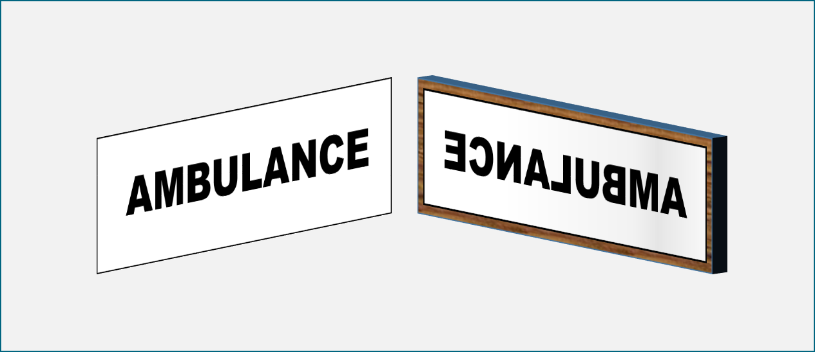

What can you say about the reflection?
For each statement, tick (✓) one column to show what you think.
 |  | I am sure this is right | I think this is right | I think this is wrong | I am sure this is wrong
A | The mirror turns the reflection round
B | The mirror reflects back what is in front of it
C | Looking through the back of the writing, we see the same as the reflection

Physics > Big idea PSL: Sound, light and waves > Topic PSL3: Making images > Key concept PSL3.1: The ray model of light to explain images
Diagnostic question
Mirror writing

Overview
Learning focus: | A plane mirror reflects light rays from each point of an object so they appear to come from distinct points behind the mirror and the reflection is seen as if it were behind the mirror.
Observable learning outcome: | Explain why an object appears back to front in a plane mirror.
Question type: | Confidence grid
Key words: | Mirror, reflection, inverted

What does the research say?
Many textbooks talk about an ‘image’ that is ‘laterally inverted’, but this is not true (Gee, 1988). It does appear that the reflection is back-to-front, but this is because of the direction in which we observe the reflection, rather than something the mirror has done to it.
In ‘looking’ at an object, an eye forms a real image of the object on its back surface (the retina). When looking at a reflection of the same object in a plane mirror, the reflected light rays from the object enter the eye in exactly the same way as they would have if they had originated from the object placed in a position behind the mirror that corresponds to where it is in front of the mirror (but without the mirror there). The reflection however appears laterally inverted. This is because to turn from looking at the side of the object facing the mirror to looking at the reflection of the object in the mirror, the observer must rotate through 180º. Likewise, if the observer were to hang upside-down from the ceiling the image would appear to rotate in the vertical plane.
Ways to use this question
Students should complete the confidence grid individually. This could be a pencil and paper exercise, or you could use an electronic ‘voting system’ or mini white boards and the PowerPoint presentation.
If there is a range of answers, you may choose to respond through structured class discussion. Ask one student to explain why they gave the answer they did; ask another student to explain why they agree with them; ask another to explain why they disagree, and so on. This sort of discussion gives students the opportunity to explore their thinking and for you to really understand their learning needs.
Differentiation
You may choose to read the questions to the class, so that everyone can focus on the science. In some situations it may be more appropriate for a teaching assistant to read for one or two students.

Equipment
For each student/pair/group (optional):
- A plane mirror
Expected answers
A is wrong – the mirror does not actively switch the reflection around.
B and C are correct.
How to respond - what next?
It is common for students and adults to think that a mirror switches the reflection of an object from left to right because when a person rises their left arm in front of a mirror, the right hand of their reflection appears to rise (Galili, Goldberg and Bendall, 1991; Galili and Goldberg, 1993; Bendall, Goldberg and Galili, 1993). If the mirror did flip the reflection left-to-right, there is no explanation for why it does not also switch the reflection from bottom to top.
What in fact happens is the mirror reflects back what is in front of it. When a person rises their left hand in front of a mirror, a reflected hand rises on the left hand side of the mirror. Holding a piece of writing up to the light and reading through the back of the paper reveals what looks like mirror writing, and this gives a clue to what is happening. If you look towards a person who is looking into a mirror and then turn 180º to look at that person’s reflection, it is you – the observer – who turns 180º and not the reflection.
If students have misunderstandings about why writing appears back-to-front in a mirror, it can help to use a mirror to observe some writing. Placing the writing very close to the front of a mirror should make it obvious that the mirror reflects back exactly what is in front of it. The following BEST ‘response activity’ could then be used to investigate these ideas more thoroughly and to consolidate understanding:
- Response activity: What turns round?
Acknowledgments
Developed by Peter Fairhurst (UYSEG).
Images: Peter Fairhurst (UYSEG).
References
Bendall, S., Goldberg, F. and Galili, I. (1993). Prospective elementary teachers' prior knowledge about light. Journal of Research in Science Teaching, 30, 1169-1187.
Galili, I. and Goldberg, F. (1993). Left-right conversions in a plane mirror. The Physics Teacher, 31, 463-466.
Galili, I., Goldberg, F. and Bendall, S. (1991). Some reflections on plane mirrors and images. The Physics Teacher, (29), 471-477.
Gee, J. K. (1988). The myth of lateral inversion. Physics Education, 23, 300-301.

